**Name:  
 -------------------------------- Baqir Sultan  
Section:**

**--------------------------------------6D**



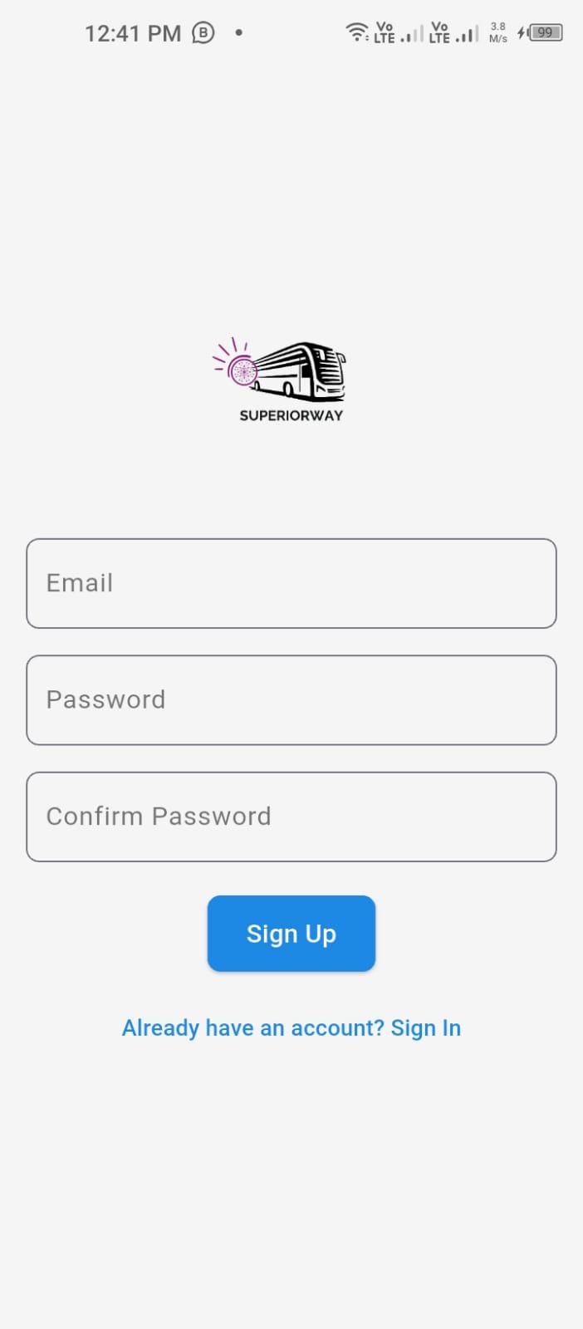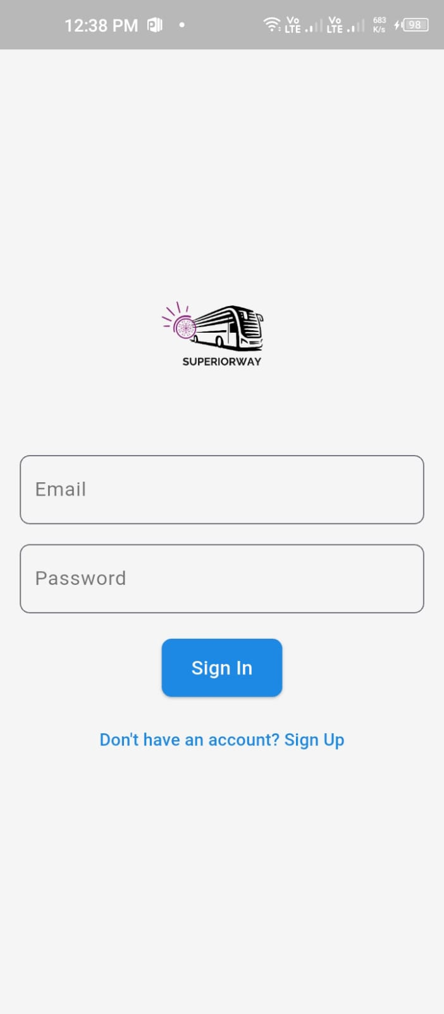

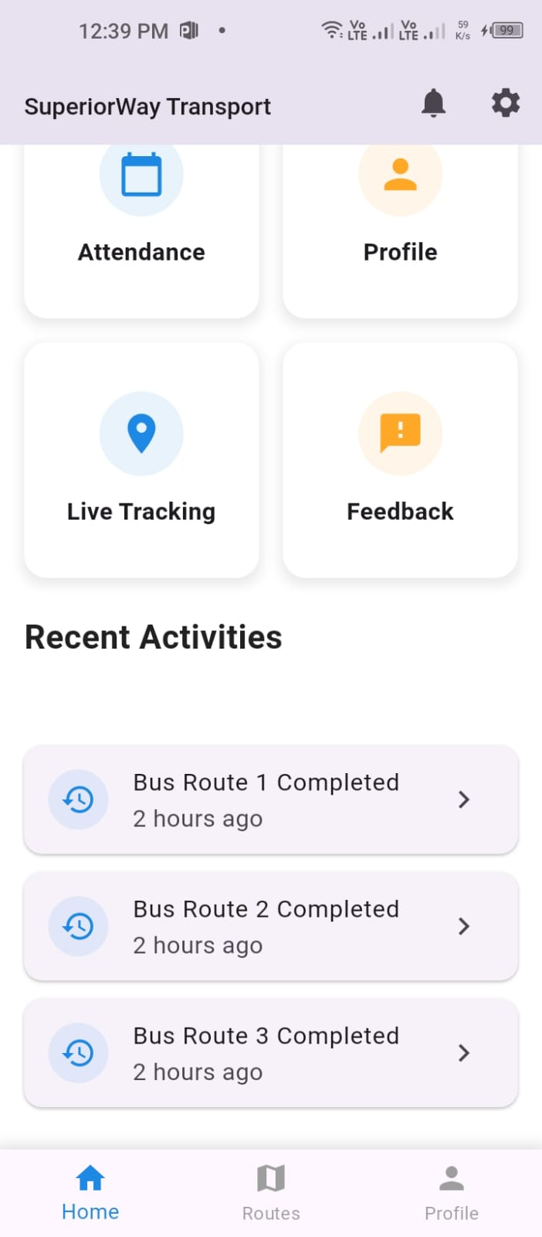

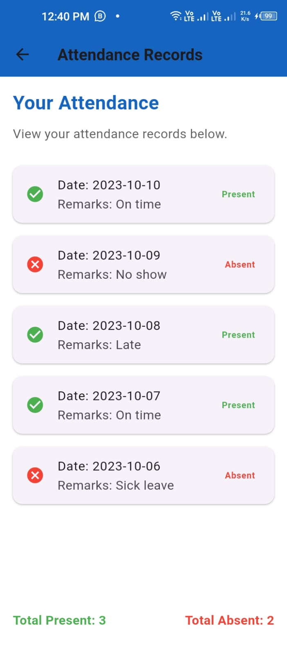

**Flutter App UI Design Explanation**

**Overview**

The Flutter app is designed to provide a seamless user experience across various devices. The UI is clean, responsive, and easy to navigate.

**Page-by-Page Breakdown**

**\*1. Login/Signup Page\***

- Secure Authentication: Firebase Authentication ensures secure login with email/password or Google sign-in.

- Simple Form UI: Structured form UI makes input fields accessible.

- *Button-Based Navigation*: Guides users through authentication smoothly.

**2. Home Page (Dashboard)**

- *Central Hub*: Displays announcements and quick links.

- *Grid-Based Layout*: Improves readability and usability.

- *List View*: Provides a scrollable, structured display of content.

**3. Attendance Page**

- *Structured Table Format*: Displays student attendance records clearly.

- *List View and Cards*: Ensure clarity and organization.

**4. Fee Payment Page**

- *Intuitive Interface*: Provides a secure online payment experience.

- *Transaction History*: Displays transaction history in a well-structured format.

**5. Bus Schedule & Live Location Pages**

- *Bus Schedule*: Displays daily routes in an easy-to-read ListView.

- *Live Location*: Integrates Google Maps API to track real-time bus movement.

**\*6. Feedback & Profile Pages**

- *Feedback Page*: Contains a form for submitting suggestions or complaints.

- *Profile Page*: Allows students to update personal information with editable fields.

**Testing**

The app is tested on an Android emulator to ensure responsiveness, smooth navigation, and a consistent UI.